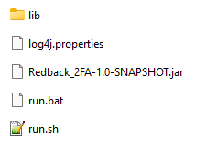

In windows, open a command terminal, then input ”./run.bat”; In linux, open a command terminal, then input ”run.sh”:

Input a new port or leave it.

After pressing enter key, open a browser, input” <http://localhost:8080/fa?email=jikuan@gmail.com>”.

Scan the QR code using any authenticator apps(e.g., google authenticator, DUO Mobile, and so forth), and then get the Time-based one-time password(TOTP) from the apps. Remember the TOTP.

Open a browser again, and then input the following address:

<http://localhost:8080/verify?email=jikuan@gmail.com&code=>640122

where the value of email parameter must be the same as the one input to generate the QR code, the value of the code must be the TOTP got just now. Therefore, if the TOTP is 134366, then the input address must be:

[http://localhost:8080/verify?email=jikuan@gmail.com&code=134366](http://localhost:8080/verify?email=jikuan@gmail.com&code=640122)

If the TOTP is input timely, the page will show the “pass” word; otherwise, it will show the “fail” word



